**Financial Analysis on Dell Technologies Inc.**

*Group No. 08*

*Section 04*

*Chintan Wagh -0788995*

*Devashish Patel - 0781214*

*Jervis Murzello - 0784028*

*Omkar Kirankumar Shinde- 0785564*

*Urvashi Prajapati -0785750*

**Business Analysis**

**Dell Inc**., originally PC's Limited (1984–88) and Dell Computer Corporation (1988–2003), is a multinational corporation that creates, develops, and produces personal computers (PCs) and a range of associated goods. The business is a major PC provider in the world. The headquarters of Dell are in Round Rock, Texas[1].

**History:**

· Michael Dell, an American who at the time was a student at the University of Texas in Austin, launched the business in 1984 under the initial moniker PC's Limited.

· Dell initially operated the company out of a dorm room, offering specialised PC upgrades.

· The business was successful, and Dell left college the following year to start making computers.

· The first computer with a Dell-exclusive design was the Turbo PC, which the company debuted in 1985.

**Current Operations:**

*Dell operates under two divisions:*

Dell Client Solutions Group (48% of fiscal 2019 revenues) – produces desktop PCs, notebooks, tablets, and peripherals, such as monitors, printers, and projectors under the Dell brand name

Dell EMC Infrastructure Solutions Group (41% of fiscal 2019 revenues) – servers, storage, and networking[2].

**List of Solutions**

Dell offers many solutions for IT infrastructure, workforce, industry and OEM.

1) IT infrastructure solution:

APEX delivers complete IT infrastructure solutions for a range of data and workload requirements, enabling you to accelerate innovation, adapt to evolving requirements and stay in control of IT operations.

2) Dell also provides security Solutions along with the IT infrastructure.

3) Their infrastructure solutions include many services like AI, Analytics, VMware, Validated designs, etc.

4) Their Workforce solutions include many services like Endpoint Security, AI Workstations, Optimizer Intelligence etc.

5) Their Industry solutions are spread across different industries like Healthcare and Life Sciences, Digital solutions, Retail, etc.

6) Along with this they also offer specific OEM solutions in collaboration.

**Macroeconomic environment (Growth- organic or mergers or acquisitions):**

Given above is the history of Dell’s mergers and acquisitions from 2010.

· 98% of the Fortune 500 are served by Dell Technologies, which also owns several market-leading companies.

· The Dell client solutions company and the Dell EMC infrastructure solutions business are the two biggest and most well-known, and both are backed by Dell EMC Services.

· Additionally, Boomi, Pivotal, RSA, SecureWorks, Virtustream, and VMware are all part of Dell Technologies.

· The focus and innovation of a start-up are combined with the global reach and services of a large company in this distinctive structure[3].

Due to its size, Dell Technologies will be able to provide clients with more innovative and cost-effective solutions by investing more in R&D, sales and marketing, services, and support.

**Industrial Competitors of Dell:**

**Top 11:-**

1) Lenovo

2) Apple

3) Samsung

4) Hewlett Packard

5) Compaq

6) Acer

7) IBM

8) Sony

9) Toshiba

10) ASUS

11) Microsoft

**Approximate market share of the company and competitors of Dell:**

Dell's market share of shipments of PC units fell from 19.5% in the fourth quarter of 2021 to **17.7 percent** in the first quarter of 2022. Following Lenovo and HP Inc. , Dell is the third largest PC vendor worldwide.

**Competitors of Dell** : Hewlett Packard Enterprise (HPE), IBM, Lenovo, NetApp, Oracle, BMC, NEC, Supermicro.

**Define CAPM and its importance in Business valuation:**

The relationship between systematic risk and expected return for assets, particularly stocks, is represented by the Capital Asset Pricing Model (CAPM).

The CAPM is widely used in finance to value risky securities and estimate predicted return for assets given its risk and cost of capital[4].

The capital asset pricing model (CAPM) is an imagined description of how securities are priced in financial markets, which in turn establishes expected returns on capital investments. The model offers a method for calculating expected return on equity by quantifying risk and translating that risk into estimates. The objective nature of the model's estimated equity costs is among CAPM's key benefits.

We can see the expected rate of return for Dell is 5.4124.

The beta value accounts for the market risk and it zigs when the market zags. It is calculated by 2 methods in the excel and the final value is taken directly from the yahoo finance webpage of Dell’s stock.

**Ratio and Valuation Analysis**

We perform Ratio analysis to understand the current status of the company as compared to the industrial standards. Valuation analysis is performed to understand the economic standing of the company. Following are the ratios that we calculated:

**Profitability Ratios**

• **Gross profit margin (GPM)**​: 0.216314229

•Operating profit margin (OPM)​: 0.046038914

•Return on assets (ROA)​: 0.059988138

•**Return on equity (ROE)**: -3.30

•Return on sales (ROS): ​0.046037549

•**Price-to-earnings ratio**: 5.953424658

•debt-to-equity: -15.99643917

•Forward Dividend & Yield: 1.32$ (3.04%)

**Liquidity Ratios**

•**Current Ratio**: 0.8010

•Quick Ratio: 0.6961

•Cash Ratio: 0.3371

We are focusing on 4 key ratios that can be used to decide whether a person should trade in this Dell stock or not.

We can see that Dell is performing poorly in terms of return on equity, price to earnings ratio as well as current ratio even though it has a higher gross profit margin as compared to Lenovo. Apple seems to be performing the best in these 3 companies.

In January 2021, the free cash flow yield for Dell Technologies fell to a five-year low of 12.4%.

**Technical Analysis**

The graph below shows the one-year stock prices as well as the change in the prices. We can see that the prices lie in the low 40’s and the high 50’s.

**Bollinger Bands**

Given below is the Bollinger Bands graph generated in Python. Bollinger Bands were first developed by John Bollinger.

Bollinger Bands are envelopes plotted at a standard deviation level above and below a simple moving average of the price. Because the distance of the bands is based on standard deviation, they adjust to volatility swings in the underlying price.[5]

We can see that the moving average is closer to the lower band which suggests that the stock is performing poorly and is likely to go down in the future.

**Stock Signals**

Given above is the stock signals graph generated in Python.

This graph shows the buy and sell signals based on the stock prices of Dell in the 1 year time period that we have taken for our project.

The next signal will be buy depending on when the stock price rises and similarly the next signal after that will be sell depending on when the stock price falls because that is how the stock signals are coded.

**Monte Carlo Simulation**

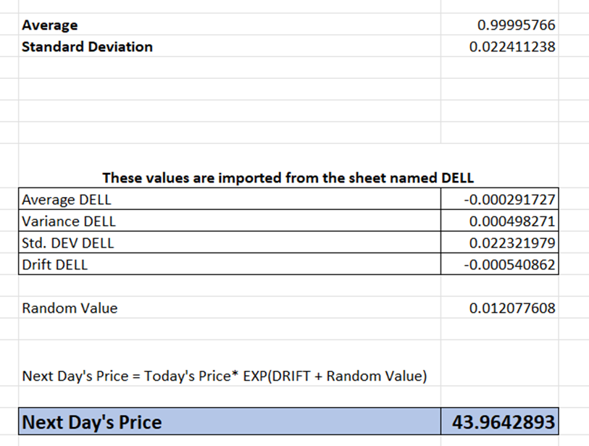

The first 2 snapshots are of the Dendrogram and the line chart showing the Monte Carlo simulation of the next 30 days for Dell’s stock prices performed in Python.

We can see that the highest stock price is greater than 46 and lowest stock price is less than 34.

At the same time, we can see that the Monte-Carlo analysis performed in excel showed us the stock price of the next day which was 43.96 when the snapshot was taken. The value keeps changing because of the functionality of the Monte-Carlo method.

**Facebook Prophet**

We have used the Facebook prophet library to conduct analysis on the Dell’s stock price for the 1 year period.

We have used the Closing price column on the y-axis and the dates on the x-axis. This analysis shows that the stock price of Dell is gradually falling even below 35 for the upcoming year.

**Recommendations**

We observed that all the methods suggest one key aspect of the current status of the stock. As shown above, we could see that the stock is performing poorly. So, our recommendations are:

1) If a new trader is interested in the Dell Technologies Inc. stock:

Buying this stock right now has potential chances of inducing heavy losses to the trader. This is because the stock is at a low price relatively and the market changes are highly volatile, so it is difficult to predict if the stock price would rise.

2) If a trader had bought the stock previously:

Selling this stock right now seems to be the best option to cut losses and look for other potential stocks.

**References**

1. <https://www.britannica.com/topic/Dell-Inc>
2. <https://en.wikipedia.org/wiki/Dell_Technologies#:~:text=Current%20operations,-Approximately%2050%25%20of&text=Dell%20Client%20Solutions%20Group%20(48,%E2%80%93%20servers%2C%20storage%2C%20and%20networking>
3. <https://www.dell.com/en-ca/dt/corporate/newsroom/announcements/2016/09/20160907-01.htm#:~:text=Dell%20Technologies%20serves%2098%20percent,supported%20by%20Dell%20EMC%20Services>.
4. <https://www.investopedia.com/terms/c/capm.asp#:~:text=The%20Capital%20Asset%20Pricing%20Model%20(CAPM)%20describes%20the%20relationship%20between,assets%20and%20cost%20of%20capital>.
5. <https://www.fidelity.com/learning-center/trading-investing/technical-analysis/technical-indicator-guide/bollinger-bands#:~:text=Bollinger%20Bands%20are%20envelopes%20plotted,Period%20and%20Standard%20Deviations%2C%20StdDev>.
6. <https://finance.yahoo.com/quote/DELL?p=DELL>
7. <https://research.facebook.com/blog/2017/02/prophet-forecasting-at-scale/>